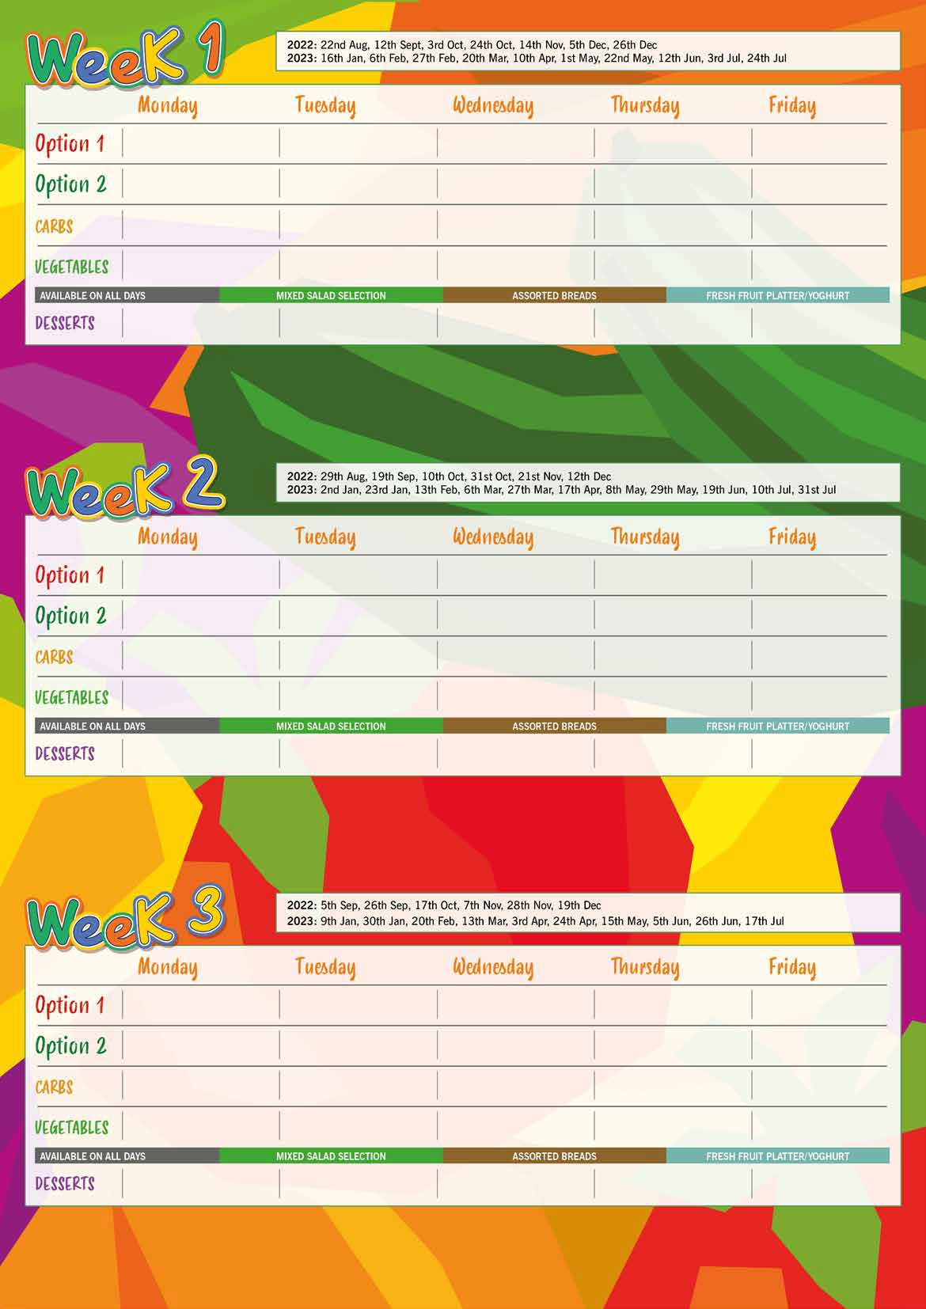

Strawberry Whip

Roasted Medley of Seasonal Vegetables

Green Beans

**Roast Chicken, Apricot Stuffing & Gravy**

**Vegetable Nuggets (V, VG)**

**Vegetable Cottage Pie (V, VG)**

**Vegetable Jambalaya (V, VG)**

Cornflake Tart

Spaghetti

Garlic Bread

**Vegetable Bolognaise(V)**

**Battered Fish**

**BBQ Chicken Wrap**

**Farm Assured Pork Sausages in Gravy**

**Margarita Pizza**

Mashed Potato

Jewelled Cous Cous

Shortbread Biscuit

**Spiced Bean Tagine (V, VG)**

**Quorn Fricassee (V, VG)**

**Sticky Chicken**

**Margarita Pizza**

**Turkey Bolognaise**

**Savory Mince**

**Roast Loin of Pork, Apple Sauce & Gravy**

**Fish Fingers or Salmon Fish Fingers**

**Vegetable Supreme Pizza (V)**

**Cheese Flan (V)**

**Quorn Dippers (V, VG)**

Pasta in Tomato Sauce Vegetable Rice

Potato & Carrot Mash

½ Jacket Potato

Herb Jacket Wedges Fluffy Rice

Chips

Minted Potatoes

Appleslaw Carrots

Green Beans Sweetcorn

Cabbage Broccoli

Baked Beans Peas

Pear & Chocolate Sponge

Oatie Cookie

Vanilla Ice Cream

**Roast Chicken, Stuffing & Gravy**

**Chinese Vegetable Stir Fry (V, VG)**

**Quorn & Vegetable Paella (V, VG)**

**Homity Pie (V)**

**Vegetarian Bolognaise (V, VG)**

**Vegetable Fingers (V, VG)**

Fluffy Rice

Herb Jacket Wedges

Parsley Potatoes Pasta

Garlic Bread Potatoes in Skins

Chips

½ Jacket Potato

Mashed Potatoes

Green Beans Roasted Medley of Seasonal Vegetables

Medley of Seasonal Vegetables Carrots

Sweetcorn Peas

Carrots Broccoli

Baked Beans Peas

Banana Cake

Carrot Cake Muffin

Chocolate Mousse

Orange Jelly with Mandarins

Strawberry Ice Cream

**Organic Meatballs in Tomato Sauce**

**Garlic Mushroom & Sweetcorn Pizza**

**Fish Fingers or Salmon Fish Fingers**

**Sweetcorn Pizza (V)**

Pasta Fluffy Rice

Roast Potatoes Swede & Potato Mash

Jewelled Cous Cous

½ Jacket Potato

Chips Fluffy Rice

Green Beans Cabbage

Broccoli Sweetcorn

Carrots Cauliflower

Medley of Vegetables Green Beans

Baked Beans Peas

Seasonal Fruit Crumble & Custard

Apple Sponge & Custard

Peach Melba Traybake

Chocolate Ice Cream