Hello and welcome to Class 1.
We look forward to meeting you and your child as they start school with us in August. We have attached some photos for you to share with your child before they start with us.
Who will my teachers be?
Class 1 teacher: Miss Martin Class 1 Nursery Nurse: Mrs Moore

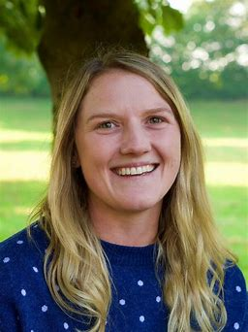

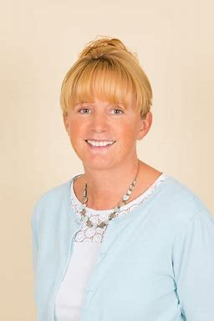

I enjoy eating cake and spending time with family.
I also enjoy walking in the countryside and working in my garden.
I enjoy baking and spending time at the sea- side.
I also enjoy watching rugby and doing lots of different sports like running, cycling and netball.

During Miss Martins PPA time, the class will be taught by:
Sports coach: Mr Riddle Music Teacher: Mrs Evans 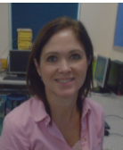

What will my classroom look like?
The classroom: Inside
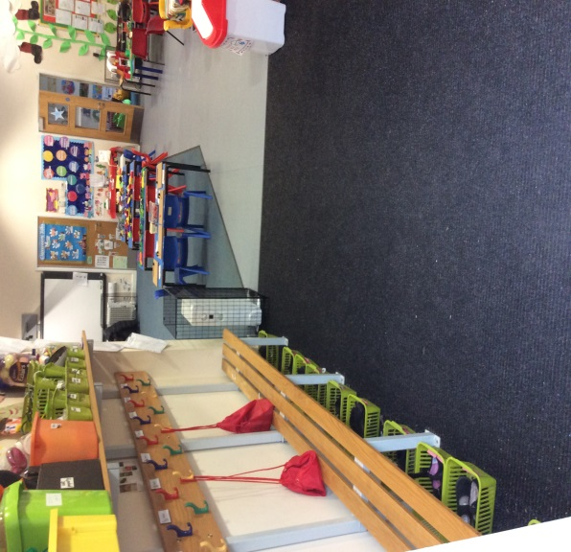
Main Classroom Area Cloak Room
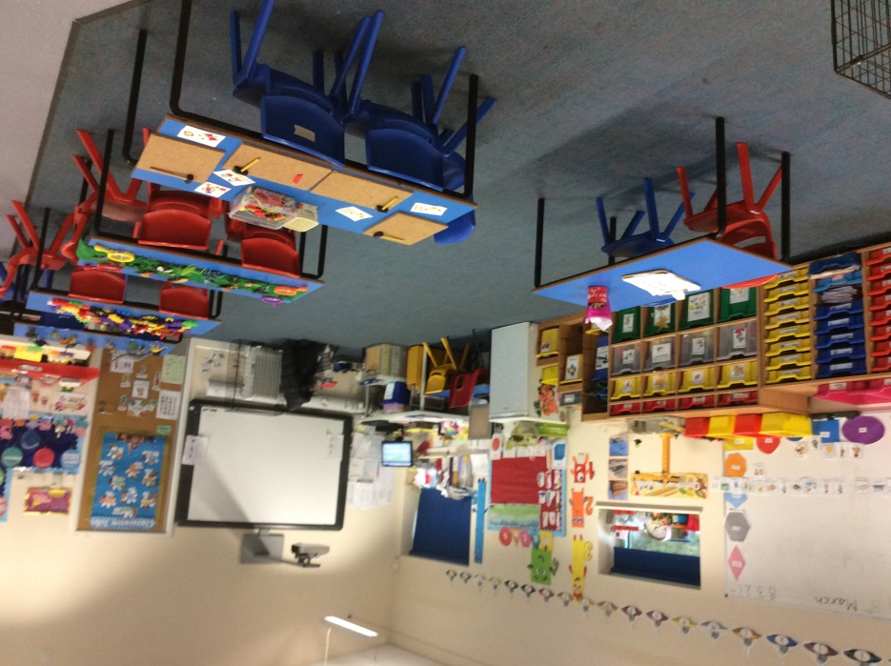
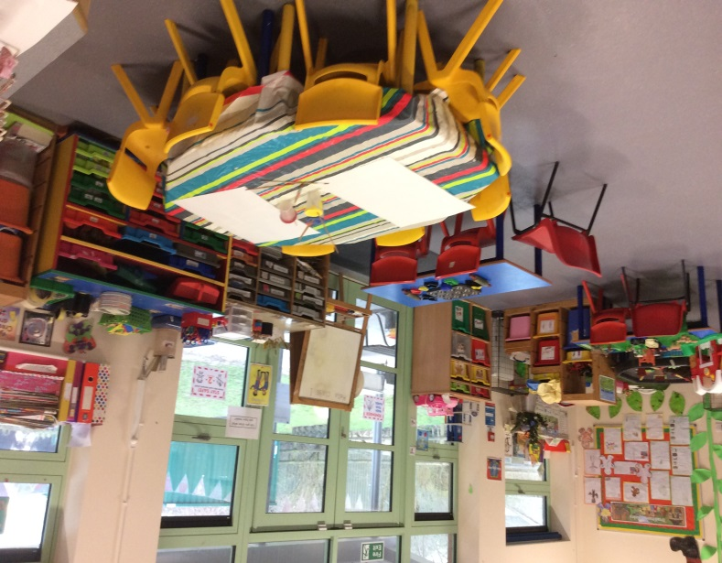
Art and Creative area Quiet/Reading Room
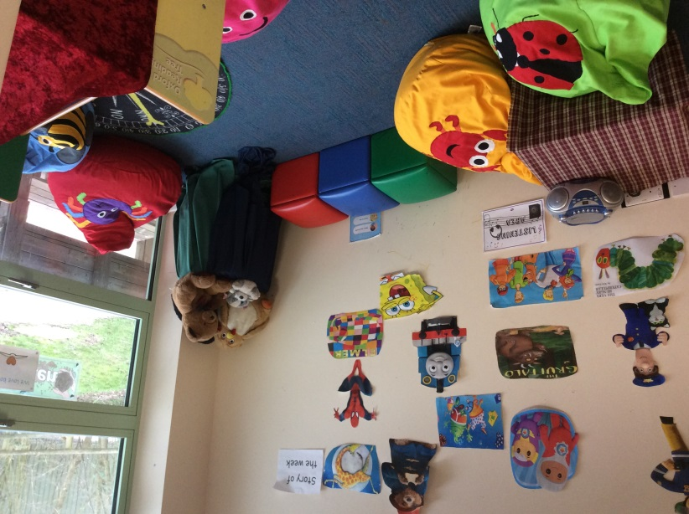

What will my classroom look like?
The classroom: Outside
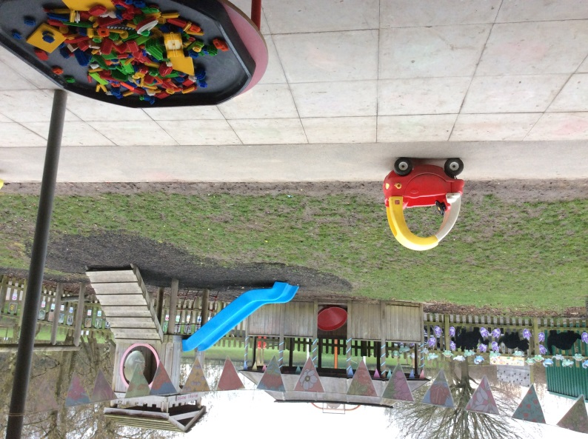
Outside Play Area

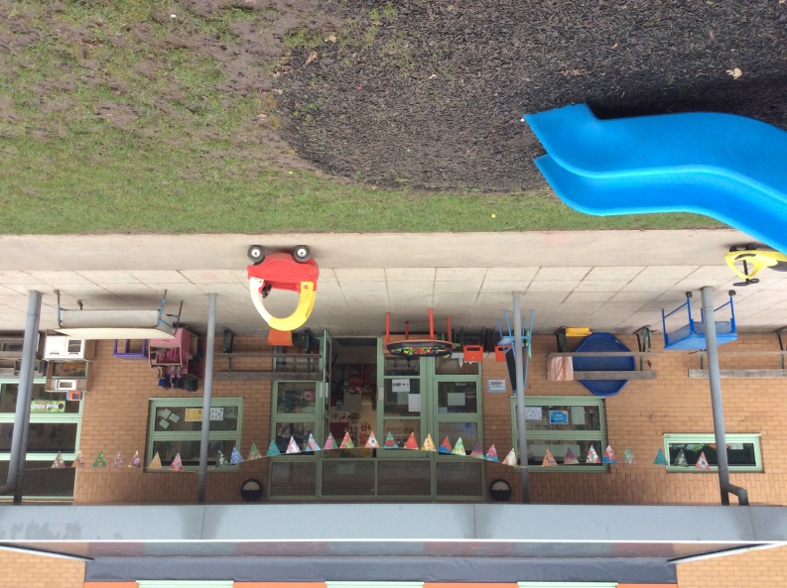

Water Play Area Mud Kitchen Area Monkey Bars
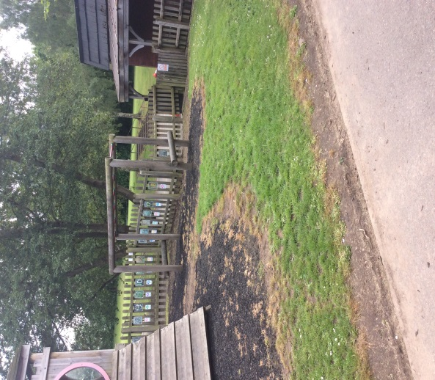
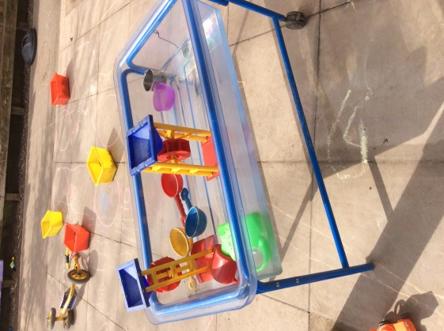
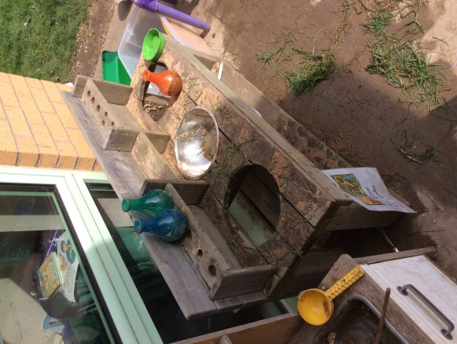

What will I do when I am at school?
The daily routine: Timetable
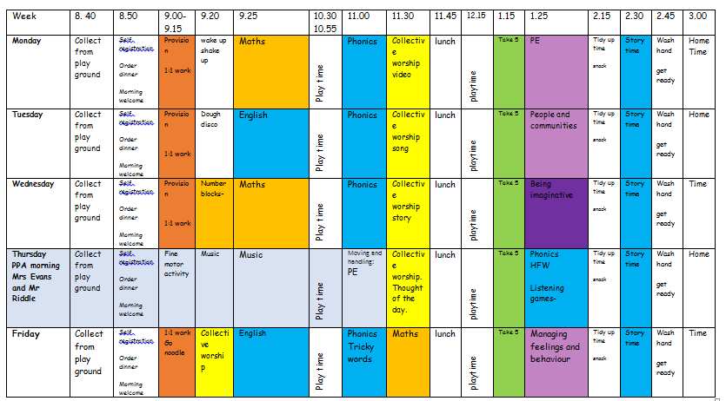
Below is a copy of our current timetable: *This is subject to change due to the nature of the EYFS curriculum. Children will learn through both adult led and child initiated activities during the day in the provision.

Please take the time to visit our website to watch our short “Introduction to Class 1” video and “Tour of Class 1’ video. These will be available on the school website shortly. These videos aim to provide you with more information about what your child needs and what they will be doing during the day in Class 1.
Useful websites
School readiness | Leicestershire County Council
Please watch the following Video:
Talking about starting school - YouTube

If you have any further questions, please contact the school office.
Kind regards, Miss Martin (Class Teacher) Mrs Moore (Class Nursery Nurse).

