Writing ideas that you can do at home with your child.
Pre-writing activities are the basis for developing a strong pencil grip.
-Ensure your child is holding their pencil correctly before they start writing.
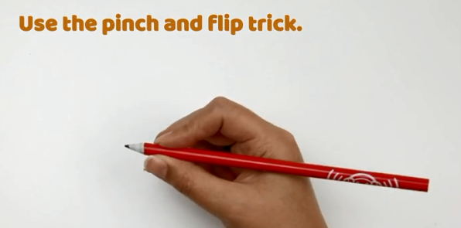
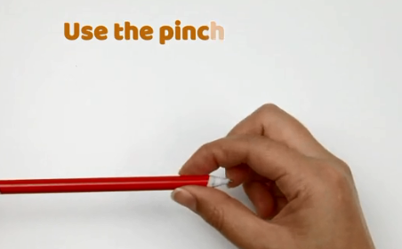
Always praise them for their efforts when writing.
1. Develop Fine Motor Skills
Developing your child’s fine motor control is fundamental in any supporting their writing. Fine motor development can be incorporated into a variety of activities including:
-Playing with playdough to strengthen students’ fingers and hands.
-Lacing and threading activities to develop hand-eye coordination.
-Cutting activities with scissors to strengthen hands.
-Open and closing activities such as using pegs on peg card activities.
2. Explore writing in messy mediums (sand, flour, paint, rice, cornflour).
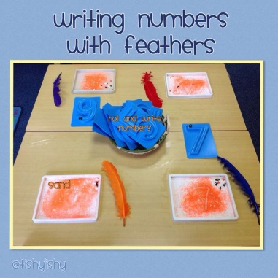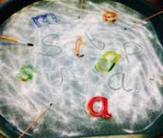
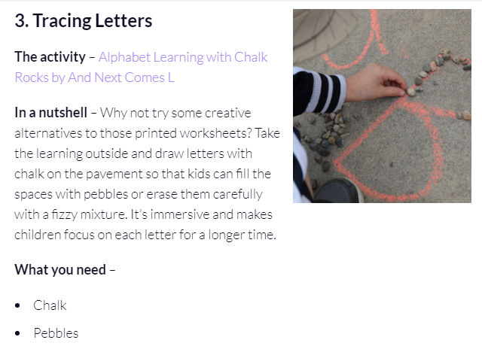
4. Secret Letters
The activity – Secret Letters by Busy Toddler
In a nutshell – Sprinkle a little bit of magic into your children’s day. Take a white crayon and write some letters or short words on a white piece of paper. Hand kids some watercolour paints and watch their amazement when they discover secret marks coming up out of nowhere…
What you need – White Crayons Watercolour Paint
- Paper Paintbrush

5. Word Shape Activities
When students are further along in their handwriting journey. Focusing on looking at word shapes is beneficial for them to understand how letters look in simple CVC words. It’s also a great way to build word and letter recognition.

